Plan View

186 m

0 m

320 m

FBP X

FBP Y

FBP Z

FCS X

FCS Y

FCS Z

Fire line

Road

320 m

160 m

300 m

250 m

150 m

100 m

50 m

Time averaged velocity

|  |
| --- |
| 0.5 m grid (50s-379s) |
| 0.75 m grid (50s-320s) |
| 1 m grid (50s-550s) |

Devices

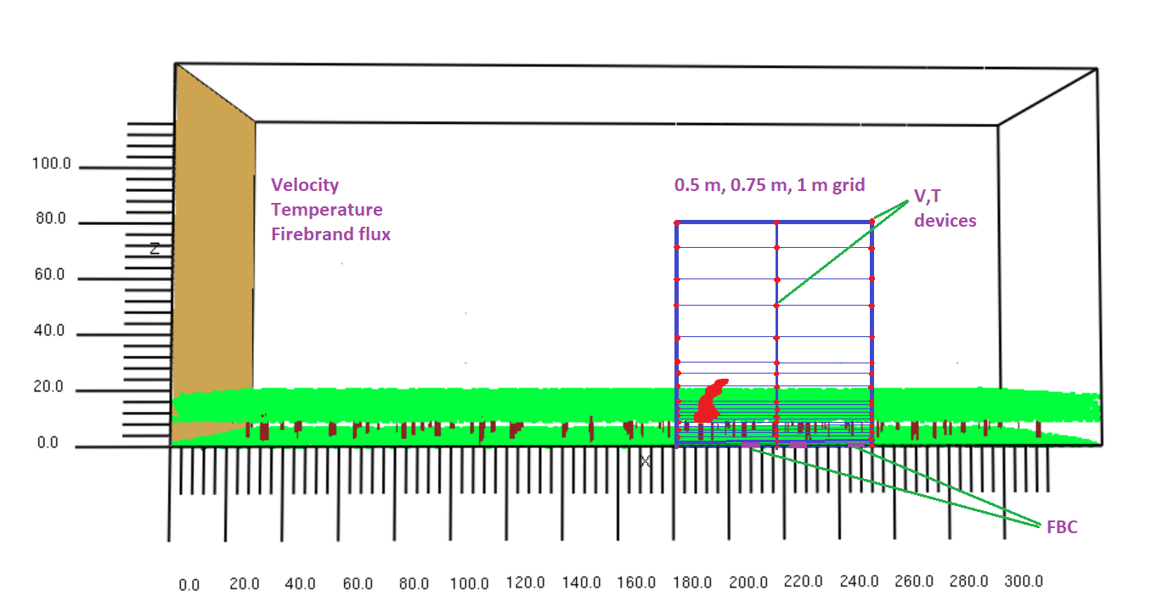

Time-series GCI (Temperature) with HRR

|  |  |  |  |
| --- | --- | --- | --- |
|  | GCI (1.00/0.75) | | |
| Height | x=182 m | x=217 m | x=252 m |
| 0 | 20.9 | 23.4 | 28.8 |
| 5 | 5.4 | 34.6 | 15.7 |
| 10 | 11.7 | 163.4 | 16.8 |
| 15 | 22.2 | 182.3 | 62.1 |
| 20 | 17.0 | 271.0 | 60.1 |
| 30 | 5.5 | 670.3 | 80.5 |
| 40 | 3.1 | 647.8 | 102.9 |
| 50 | 1.3 | 436.2 | 177.8 |
| 60 | 1.7 | 61.3 | 409.6 |
| 70 | 2.0 | 1.3 | 353.8 |
| 80 | 0.9 | 0.8 | 361.6 |

**Fire line height is 9 m above the ground

Temperature profile at Y=0, after initiating fire

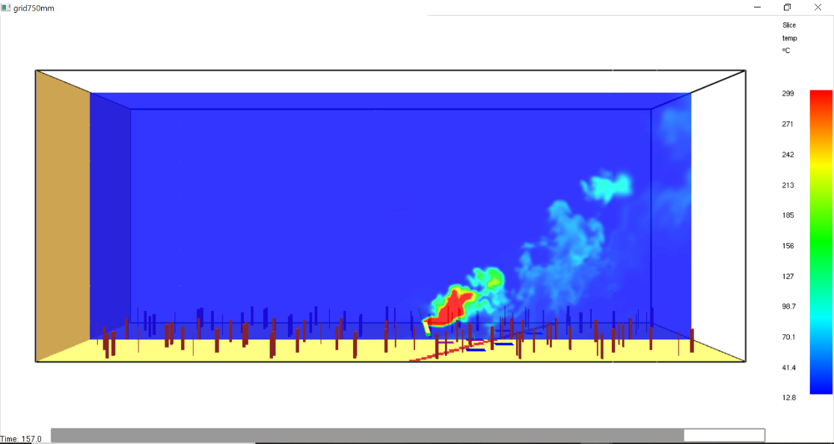

Fireline nature (Top view)

|  |  |
| --- | --- |
| 0.75 m grid | 1.00 m grid |
| At 123 s | |
| At 130s | |
| At 140s | |
| At 150s | |
| At 160s | |
| At 170s | |

Velocity profile at Y=0, after initiating fire

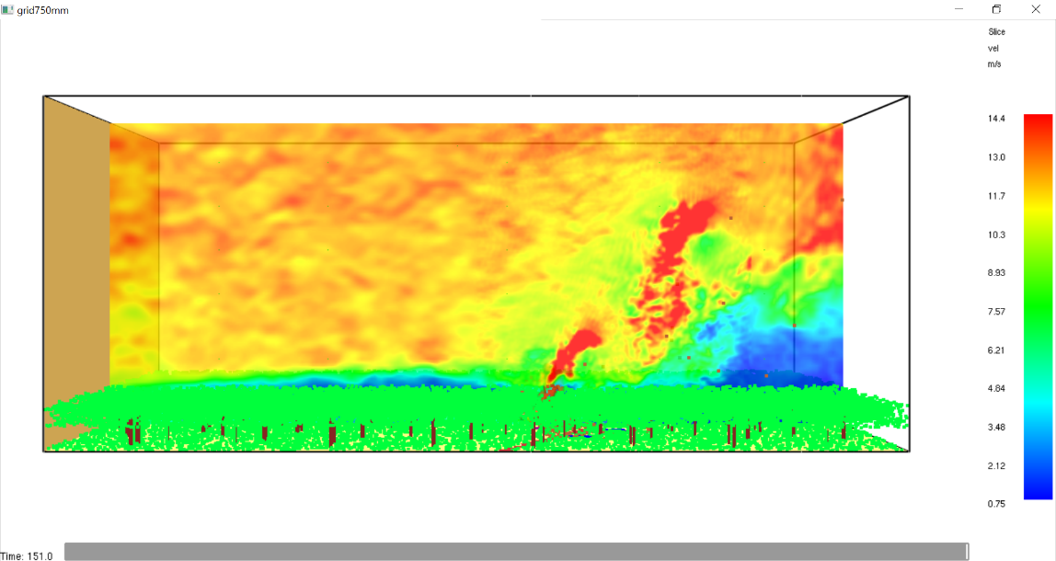

Temperature vs time example

|  |
| --- |
|  |
|  |

Firebrand flux

|  |  |  |  |
| --- | --- | --- | --- |
| location | Firebrand flux (pcs/m2.s) | | Difference (%) |
| Grid 750 mm | Grid 1000 mm |
| FCS X | 0.0302 | 0.0395 | 23.5 |
| FCS Y | 0.2732 | 0.5149 | 46.9 |
| FCS Z | 0.9921 | 0.7552 | 23.8 |

Average wind velocity (m/s) at anemometer (17 m height)

|  |  |  |
| --- | --- | --- |
| Grid size | Experiment | Simulation 5DTT |
| 0.5 m | 1.40.6  Occasional gusts up to 4.4 m/s  Lulls of 0.5 m/s | 1.39 |
| 0.75 m | 1.89 |
| 1 m | 1.40 |